**EEE 424 Coding Assignment 1**

In this assignment the aim was to compute and compare different Discrete Fourier Transform (DFT) methods.

**Q1)**

In this part of the assignment 5 different DFT approaches are implemented and applied to 3 different length arrays (N = 32, 256, 4096). Whole code of this question is provided in **Appendix A**.

These five different approaches are:

* DFT summation: Direct DFT Summation formula
* DFT matrix: DFT Matrix algorithm
* FFT-DIT: Fast Fourier Transform (FFT) using the decimation-in-time algorithm
* FFT-DIF: FFT using decimation-in-frequency algorithm
* fft: MATLAB’s built-in FFT command

Since the steps (a) to (h) are repeated for different lengths of arrays, steps (a)-(h) are written as a function called **steps_a_h(x)** which is provided in **Appendix A**.

First, a complex array of length N = 32 is created with the given code snippet:

rng(2,"twister")

N = 32;

real_part = randn(1,N);

imag_part = randn(1,N);

x = real_part + 1i*imag_part;

**a)**

Real and imaginary parts of x[n] of length N = 32 are plotted with the following code snippet:

n = 0:N-1;

figure;

subplot(2,1,1);

stem(n, real(x), 'filled');

title('Real Part of x[n]');

xlabel('n');

ylabel('Re\{x[n]\}');

xlim([0 N-1]);

grid on;

subplot(2,1,2);

stem(n, imag(x), 'filled');

title('Imaginary Part of x[n]');

xlabel('n');

ylabel('Im\{x[n]\}');

xlim([0 N-1]);

grid on;

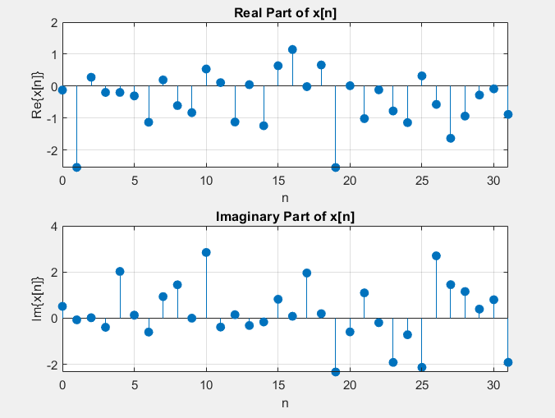

***Fig.1*** *Real and Imaginary parts of x[n], N= 32*

**b)**

The definition of DFT in summation form:

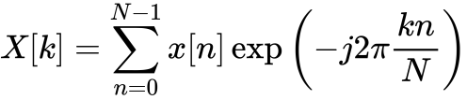

In order to compute N = 32 point DFT of the array x[n] using the direct definition in summation form the following function is defined:

function X = DFT_summation(x)

N = length(x);

X = zeros(1, N);

for k = 0:N-1

for n = 0:N-1

X(k+1) = X(k+1) + x(n+1) * exp(-1i * 2 * pi * k * n / N);

end

end

end

In order to compute DFT of x[n], the function is called as follows:

t1 = tic;

Xsum = DFT_summation(x);

elapsed_time = toc(t1);

fprintf('Elapsed time for DFT_summation is %.6f seconds.\n', elapsed_time);

plotDFT(Xsum, 'Summation Formula')

**c)**

DFT matrix defined as:

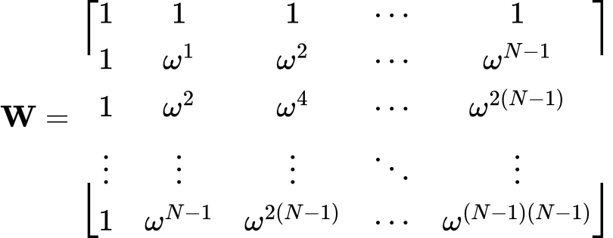

where:

C:/Users/User/AppData/Local/Temp/wps.hvBdZjwps

In order to create DFT matrix and compute the DFT of the array x[n] using the DFT matrix the following function is defined:

function X = DFT_matrix(x)

N = length(x);

WN = exp(-1i * 2 * pi / N);

DFT_mat = zeros(N, N);

for k = 0:N-1

for n = 0:N-1

DFT_mat(k+1, n+1) = WN^(k * n);

end

end

X = (DFT_mat * x.').';

end

**d)**

DFT of x[n] calculated with the DFT matrix as follows:

wps

In order to compute DFT of x[n], the DFT matrix function is called as follows:

t2 = tic;

X_mat = DFT_matrix(x);

elapsed_time = toc(t2);

fprintf('Elapsed time for DFT_matrix is %.6f seconds.\n', elapsed_time);

plotDFT(X_mat, 'DFT matrix')

**e)**

Decimation-in-time Fast Fourier Transform is defined as recursively dividing the even and odd samples:

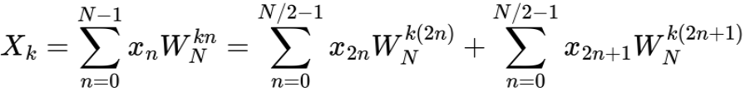

where:

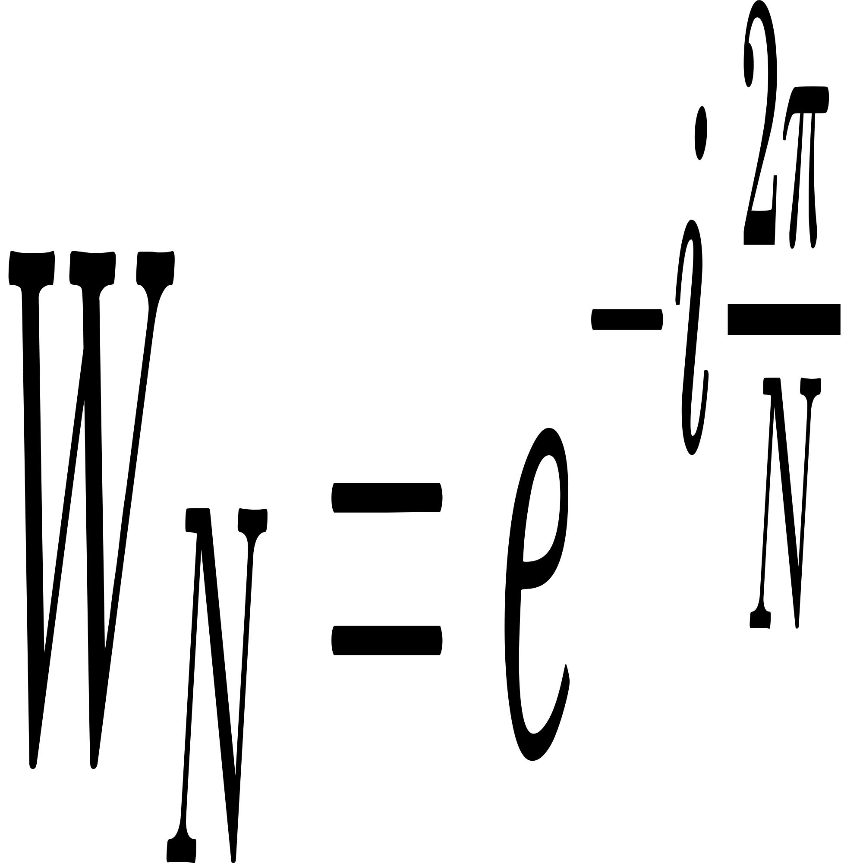

Key Steps in the FFT DIT Algorithm:

1. Divide: The sequence x is split into two smaller subsequences: one containing the even-indexed elements and the other containing the odd-indexed elements.
2. Conquer: The FFT of the even and odd subsequences is computed recursively.
3. Combine: The results of the even and odd subsequences are combined using a "twiddle factor" W, which is a complex exponential factor, to form the final result.

In order to compute the DFT of the array x[n] using the FFT decimation-in-time algorithm the following function is defined:

function X = FFT_DIT(x)

N = length(x);

if N == 1

X = x;

else

% Divide

x_even = x(1:2:end);

x_odd = x(2:2:end);

% Conquer

X_even = FFT_DIT(x_even);

X_odd = FFT_DIT(x_odd);

% Combine

WN = exp(-1i * 2 * pi / N);

W = 1;

X = zeros(1, N);

for k = 1:N/2

X(k) = X_even(k) + W * X_odd(k);

X(k + N/2) = X_even(k) - W * X_odd(k);

W = W * WN;

end

end

end

In order to compute DFT of x[n], the FFT DIT function is called as follows:

t3 = tic;

X_DIT = FFT_DIT(x);

elapsed_time = toc(t3);

fprintf('Elapsed time for FFT_DIT is %.6f seconds.\n', elapsed_time);

plotDFT(X_DIT, 'FFT-DIT')

**f)**

N point DFT defined as:

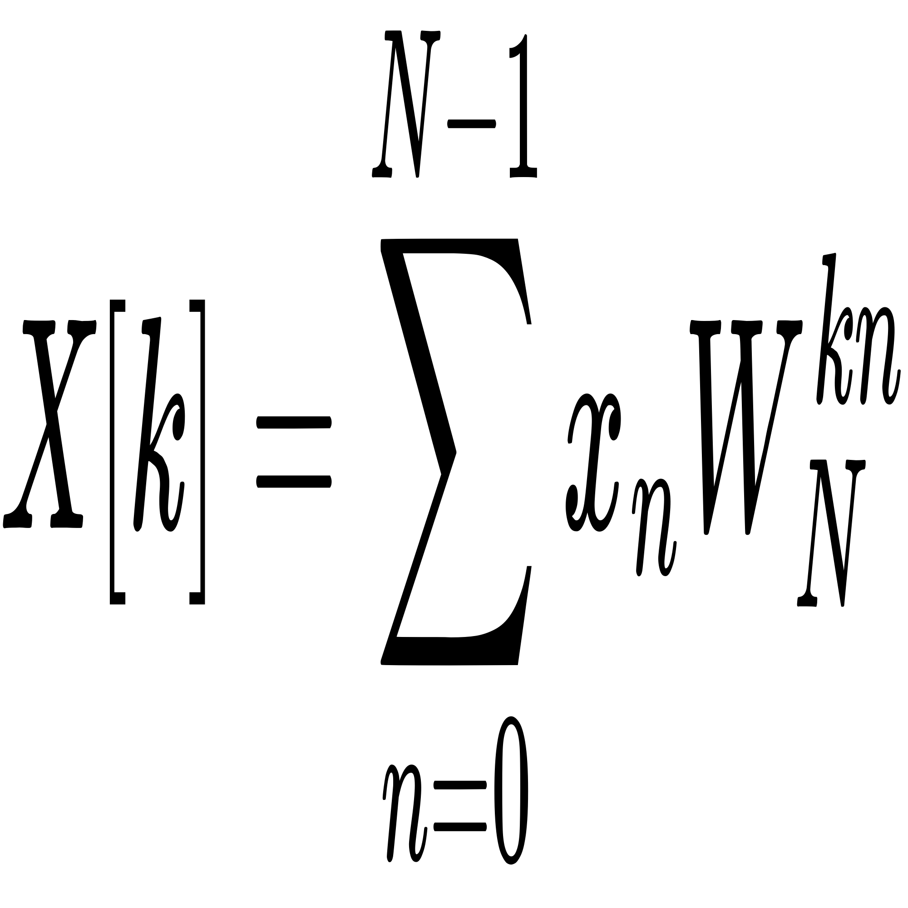

where:



Decimation-in-frequency Fast Fourier Transform can be calculated by putting k = 2r in the summation formula then we get:

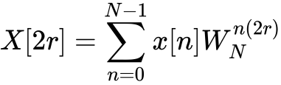

Split into two sums:

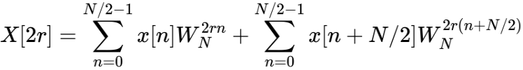

Rearranging the terms:

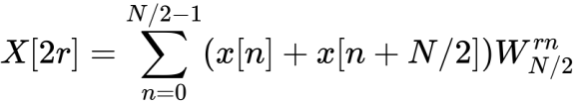

This N/2 DFT of first and second half summed. X[2r+1] can be found similarly.

This can be repeated recursively.

In order to compute the DFT of the array x[n] using the FFT decimation-in-frequency algorithm the following function is defined:

function X = FFT_DIF(x)

N = length(x);

if N == 1

X = x;

else

X = x;

% Butterfly stage

for k = 1:N/2

temp = X(k);

X(k) = temp + X(k + N/2);

X(k + N/2) = (temp - X(k + N/2)) * exp(-1i * 2 * pi * (k - 1) / N);

end

% Recursive stage

X(1:N/2) = FFT_DIF(X(1:N/2));

X(N/2+1:N) = FFT_DIF(X(N/2+1:N));

end

end

In order to compute DFT of x[n], the FFT DIF function is called as follows:

t4 = tic;

X_DIF = bitrevorder(FFT_DIF(x));

elapsed_time = toc(t4);

fprintf('Elapsed time for FFT_DIF is %.6f seconds.\n', elapsed_time);

plotDFT(X_DIF, 'FFT-DIF')

**g)**

In order to compute DFT of x[n] using the MATLAB’s built-in FFT command, the fft command is called as follows:

t5 = tic;

X_fft = fft(x);

elapsed_time = toc(t5);

fprintf('Elapsed time for fft is %.6f seconds.\n', elapsed_time);

plotDFT(X_fft, 'FFT')

**h)**

For plotting purposes, **plotDFT(X, str)** function is defined. That takes the name of the algorithm (str) and DFT of x[n] (X[k]) and plots the magnitude and phase graphs of X[k]. The function is visible in **Appendix A**.

The magnitude and phase graphs of X[k] for each algorithm when N = 32 are below in Figures 2-6:

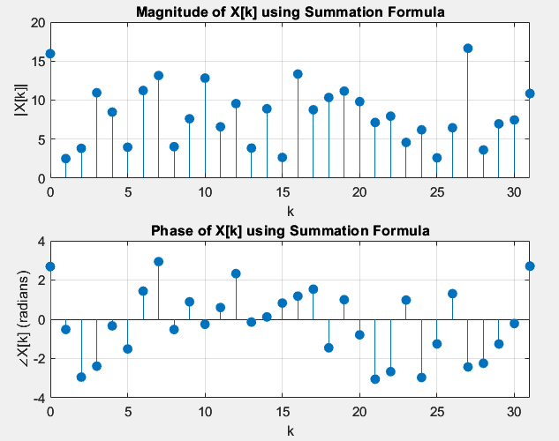

***Fig.2*** *DFT using summation formula, N = 32*

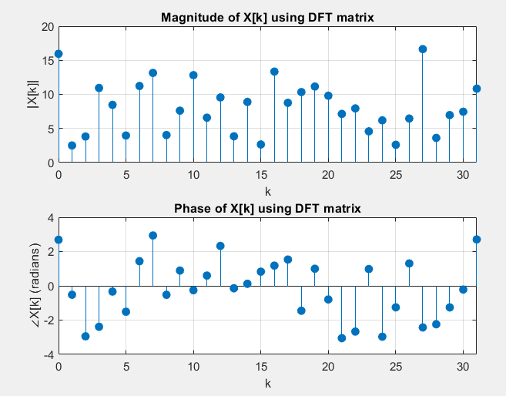

***Fig.3*** *DFT using DFT matrix, N = 32*

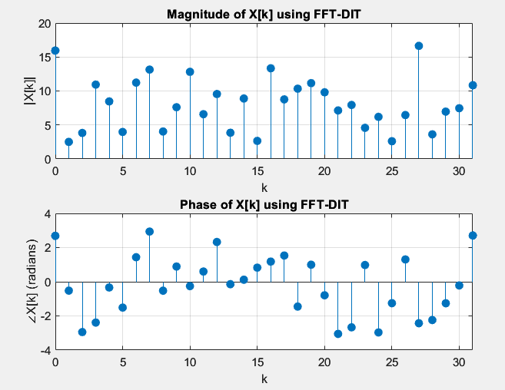

***Fig.4*** *DFT using FFT-DIT, N = 32*

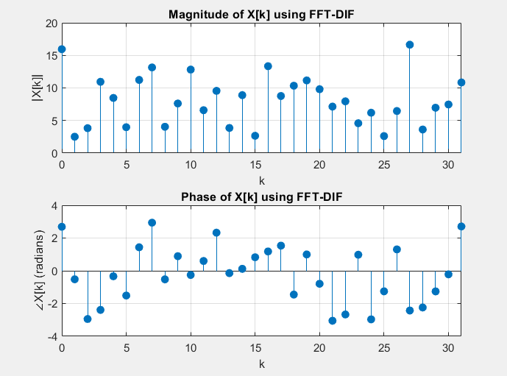

***Fig.5*** *DFT using FFT-DIF, N = 32*

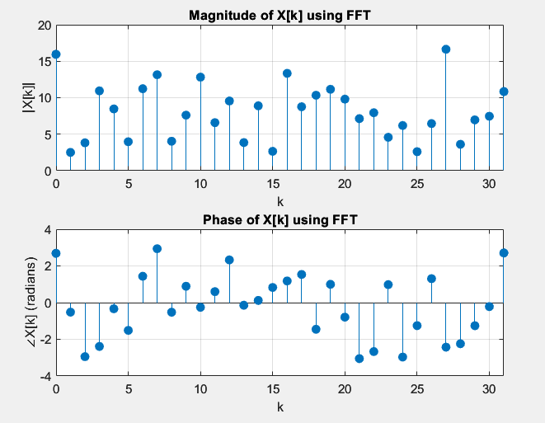

***Fig.6*** *DFT using FFT, N = 32*

Comparing Figures 2-6 it is visible that each algorithm produces equivalent results.

The algorithms are also compared using the difference of the norms between arrays. Each custom algorithm is compared with the built-in FFT command to check whether the norm is infinitesimally small or not (close to machine precision). The following code snippet computes the differences:

disp(['Summation Formula: ', num2str(norm(X_fft - Xsum))]);

disp(['DFT matrix: ', num2str(norm(X_fft - X_mat))]);

disp(['FFT-DIT: ', num2str(norm(X_fft - X_DIT))]);

disp(['FFT-DIF: ', num2str(norm(X_fft - X_DIF))]);

disp(['fft: ', num2str(norm(X_fft - X_fft))]);

And the output is as following:

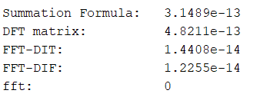

***Fig.7*** *Difference of the norms between the algorithms, N = 32*

From Fig.7 it is evident that the difference of the norms are very close to zero, therefore, all the algorithms generates the same result.

**i)**

Now, steps (a) - (h) repeated for a array of length with N = 256. The vector is crated using the provided code snippet as follows:

rng(2,"twister")

N = 256;

real_part = randn(1,N);

imag_part = randn(1,N);

x = real_part + 1i*imag_part;

And the steps (a)-(h) are repeated using the above mentioned custom function **steps_a_h(x)** (see Appendix A):

steps_a_h(x);

Real and imaginary parts of x[n] of length N = 256 are plotted:

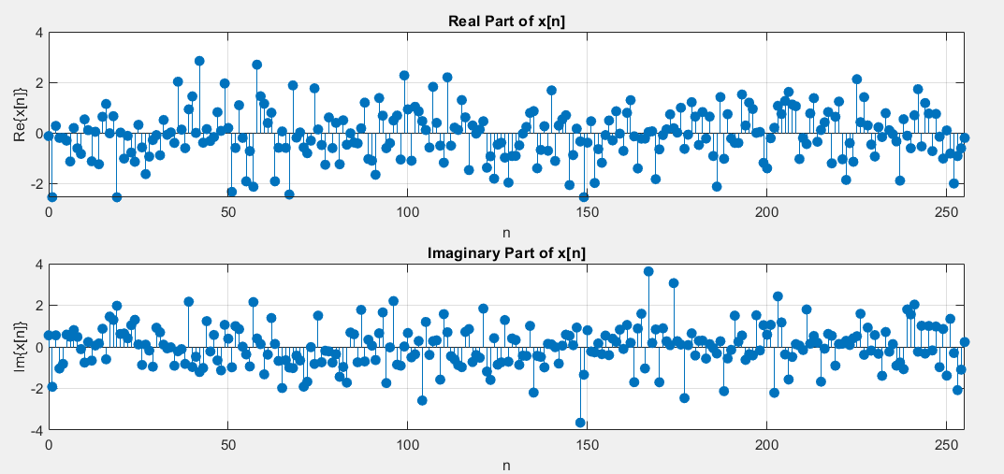

***Fig.8*** *Real and Imaginary parts of x[n], N= 256*

The magnitude and phase graph of the different algorithms:

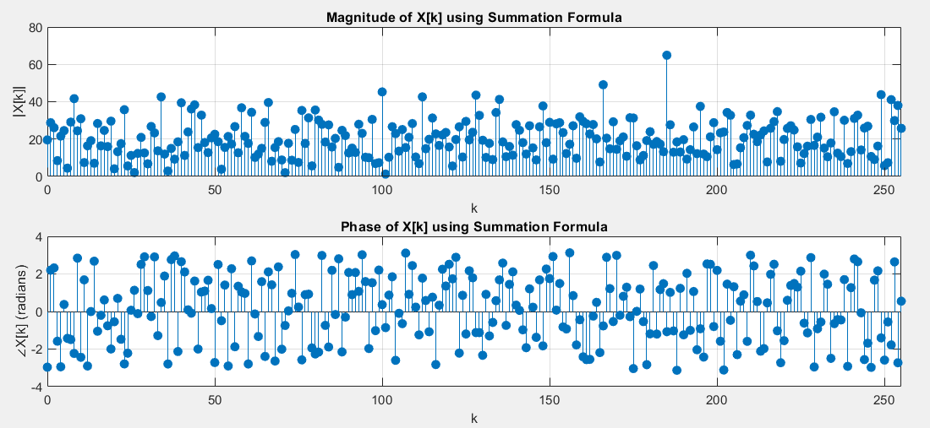

***Fig.9*** *DFT using summation formula, N = 256*

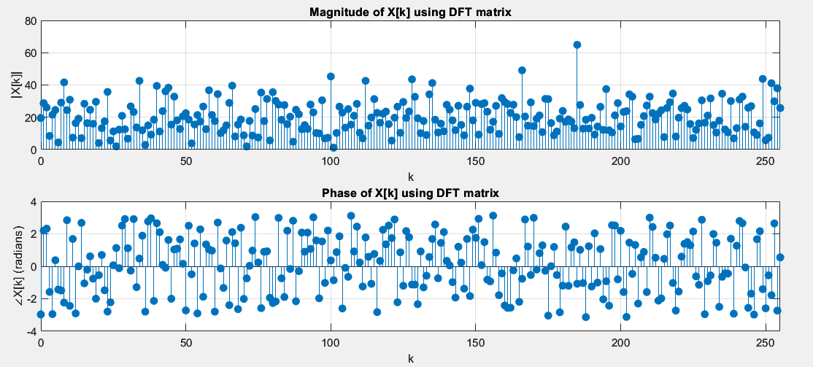

***Fig.10*** *DFT using DFT matrix, N = 256*

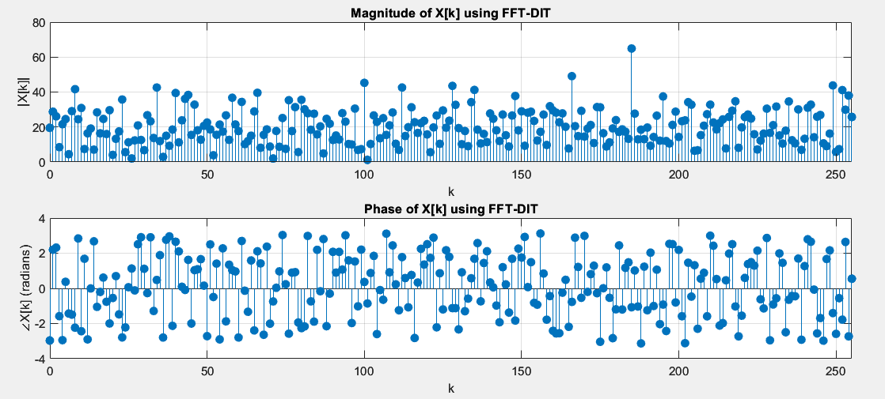

***Fig.11*** *DFT using FFT-DIT, N = 256*

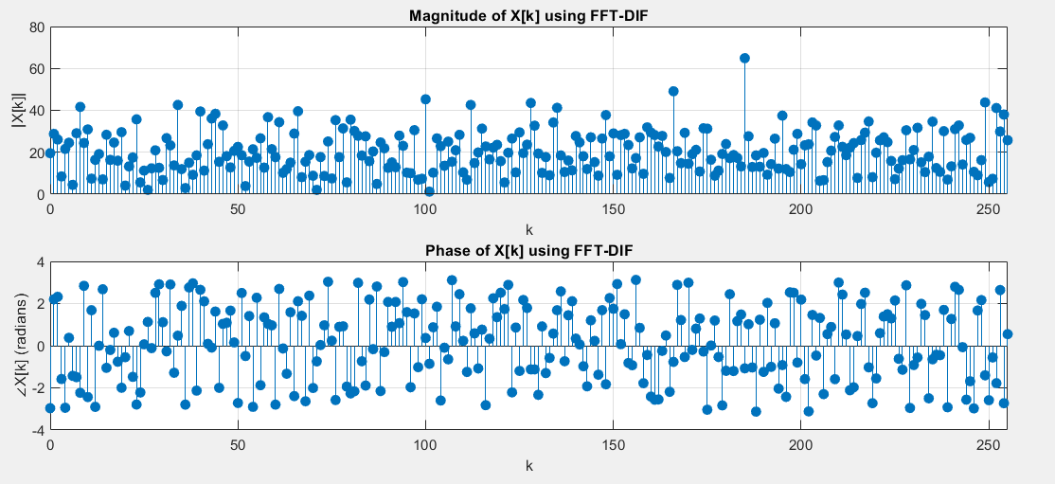

***Fig.12*** *DFT using FFT-DIF, N = 256*

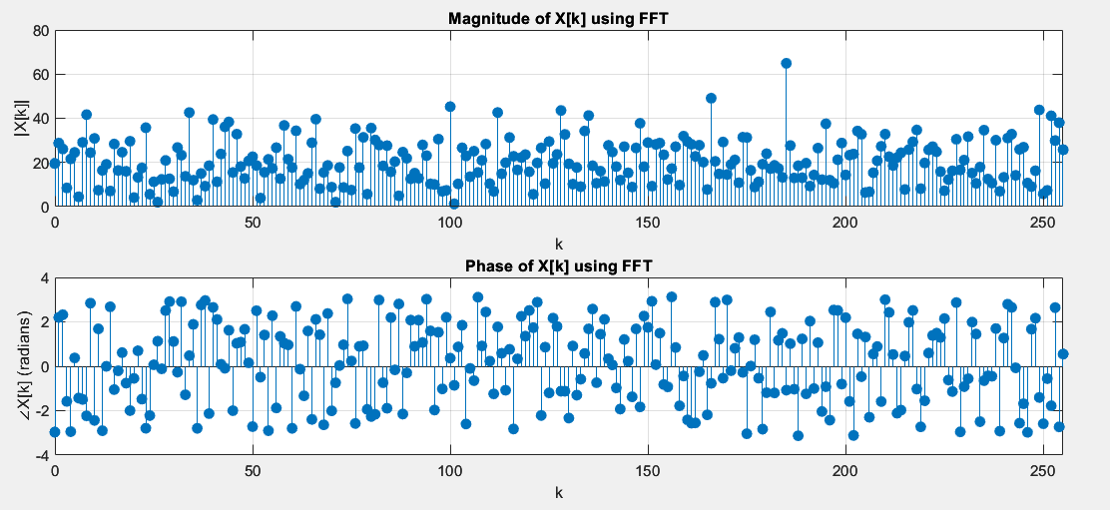

***Fig.13*** *DFT using FFT, N = 256*

Comparing Figures 9-13 it is visible that each algorithm produces equivalent results.

Differences of the norms of different algorithms:

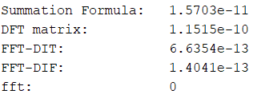

***Fig.14*** *Difference of the norms between the algorithms, N = 256*

From Fig.14 it is evident that the difference of the norms are very close to zero, therefore, all the algorithms generates the same result.

**j)**

Now, steps (a) - (h) repeated for a array of length with N = 2^12. The vector is crated using the provided code snippet as follows:

rng(2,"twister")

N = 2^12;

real_part = randn(1,N);

imag_part = randn(1,N);

x = real_part + 1i*imag_part;

And the steps (a)-(h) are repeated using the above mentioned custom function **steps_a_h(x)** (see Appendix A):

steps_a_h(x);

Real and imaginary parts of x[n] of length N = 2^12 are plotted:

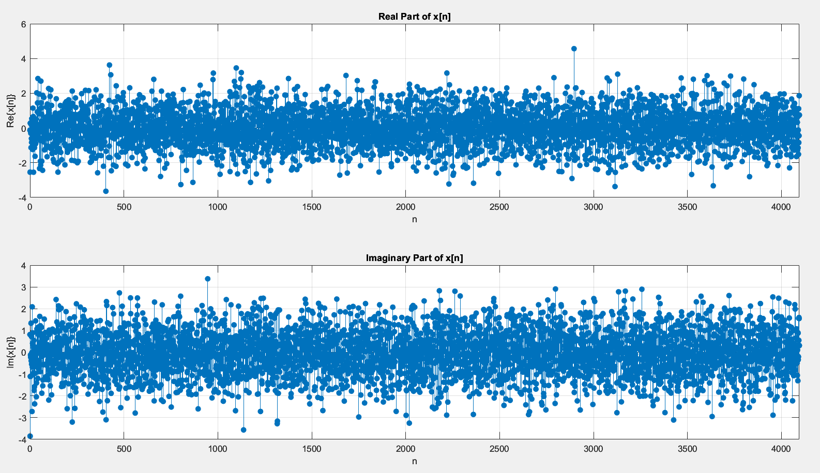

***Fig.15*** *Real and Imaginary parts of x[n], N=* 2^12

The magnitude and phase graph of the different algorithms:

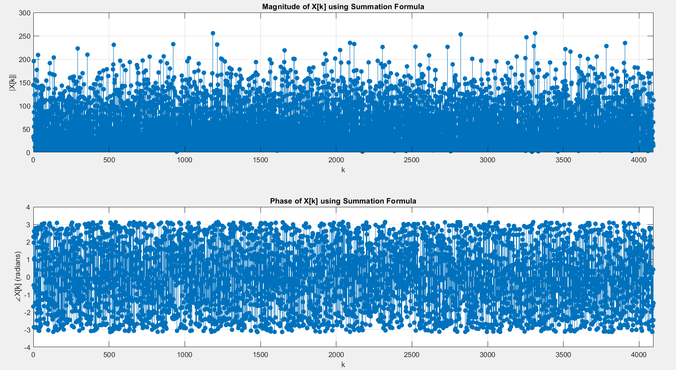

***Fig.16*** *DFT using summation formula, N =* 2^12

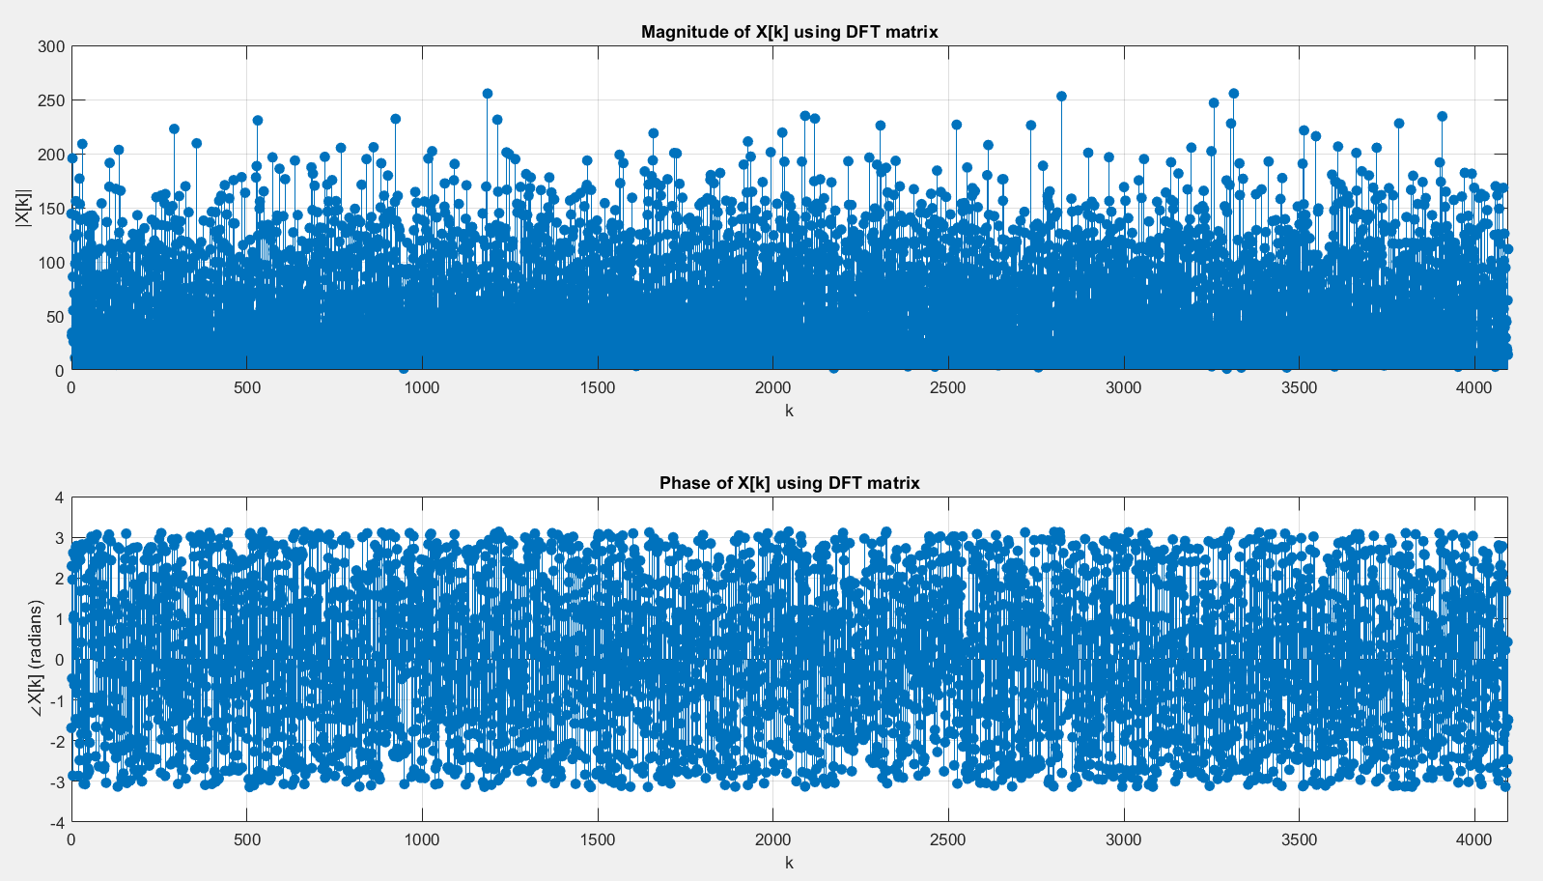

***Fig.17****DFT using DFT matrix, N =* 2^12

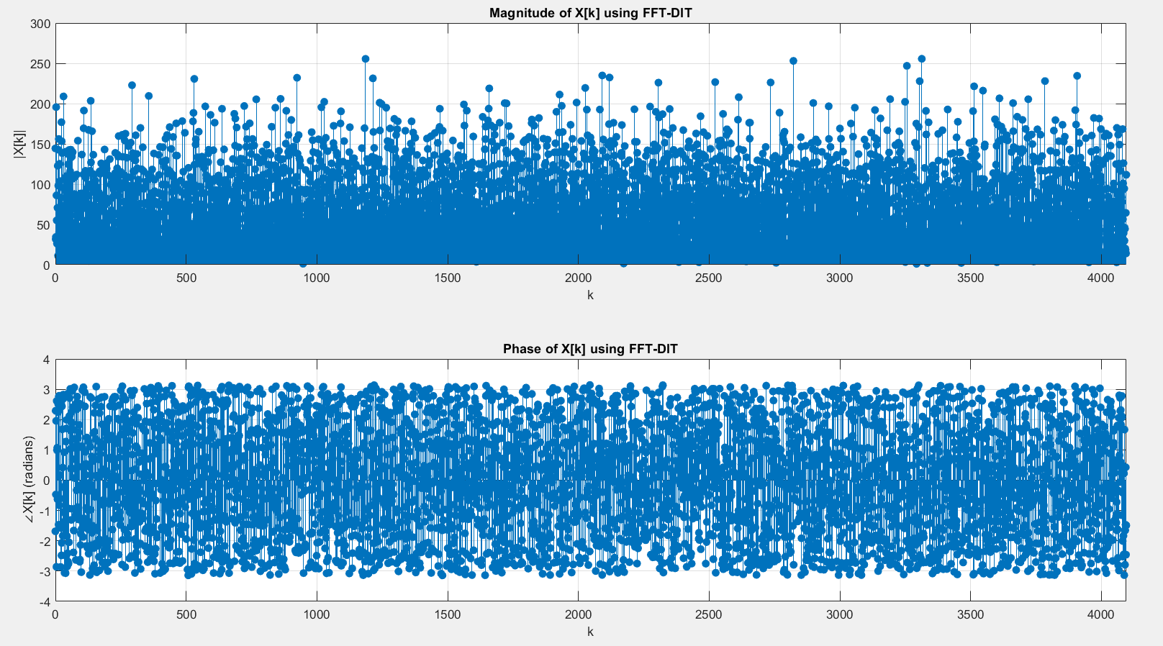

***Fig.18*** *DFT using FFT-DIT, N =* 2^12

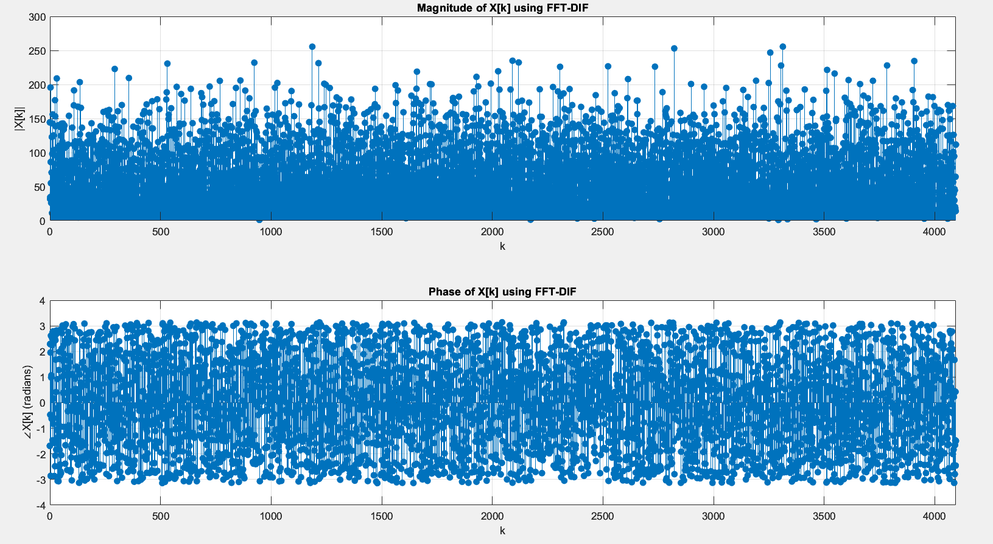

***Fig.19*** *DFT using FFT-DIF, N =* 2^12

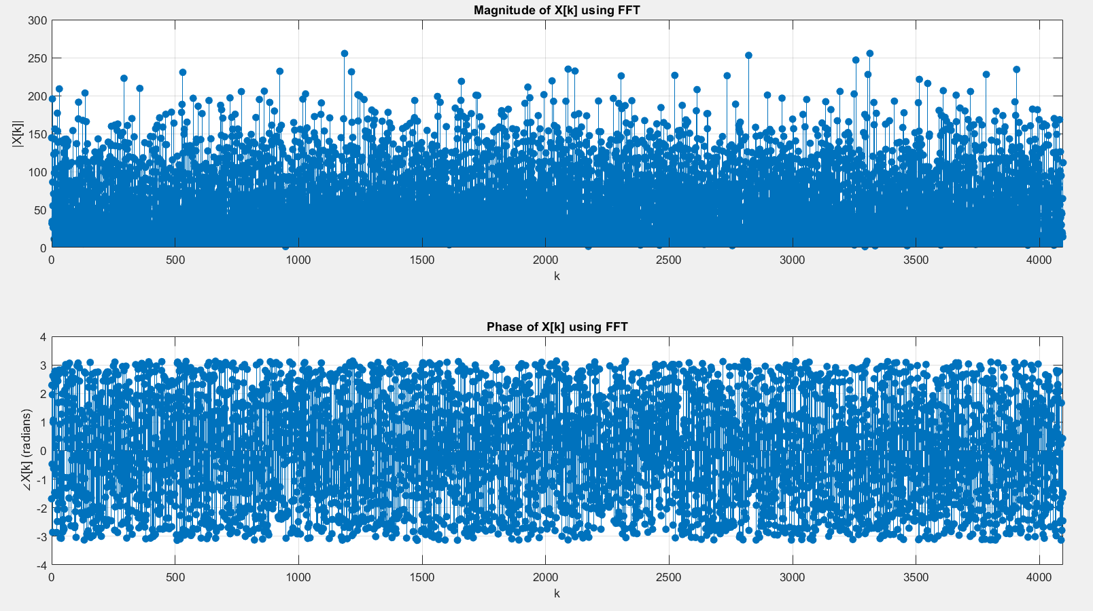

***Fig.20*** *DFT using FFT, N =* 2^12

Comparing Figures 16-20 it is visible that each algorithm produces equivalent results.

Differences of the norms of different algorithms:

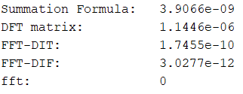

***Fig.21*** *Difference of the norms between the algorithms, N =* 2^12

From Fig.21 it is evident that the difference of the norms are very close to zero, therefore, all the algorithms generates the same result.

**k)**

Time it takes for each algorithm is calculated using *tic* and *toc* commands. The results are gathered in the Table 1.

|  |  |  |  |
| --- | --- | --- | --- |
|  | N = 32 | N = 256 | N = 2^12 |
| Part (b) | 0.001658 s | 0.018429 s | 4.120413 s |
| Part (d) | 0.001597 s | 0.034487 s | 8.044837 s |
| Part (e) | 0.000797 s | 0.004292 s | 0.019670 s |
| Part (f) | 0.016621 s | 0.004007 s | 0.032825 s |
| Part (g) | 0.000464 s | 0.002475 s | 0.000225 s |

***Table 1:*** *Time it takes to compute different DFT approaches on signals of varying length*

Table 1 shows the time taken by five different DFT approaches for three signal lengths (N = 32, 256, and 4096). As expected, the time increases with larger signal sizes, and there is a significant variation in time across different methods. The direct DFT summation (part b) and DFT matrix (part d) exhibit a much slower computation time for larger arrays compared to the FFT-based approaches. Specifically, the FFT-DIT (part e) and FFT-DIF (part f) methods perform significantly faster as the signal length increases, highlighting the advantages of these algorithms in handling large data sets. The built-in MATLAB FFT (part g) shows the fastest computation time, aligning with theoretical expectations that FFT-based methods reduce complexity from O(N^2) in the direct summation to O(NlogN). These findings confirm the efficiency of FFT algorithms, particularly as the signal length grows.

**Q2)**

In this part, we are focusing on a uncommon scenario where we are computing FFT of a signal length N = 3v instead of N = 2v. In particular, 9-pt signal array. Whole code of this question is provided in **Appendix B**.

**a)**

Following similar steps with part (f) where we computed FFT of a signal with length N = 2v using the decimation-in-frequency algorithm.

N point DFT defined as:



where:



So in order to find X[k], let k = 3r, where r = 0 ,…, N/3-1

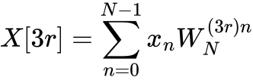

Split this over 3 sums with N/3 intervals.



wps

C:/Users/User/AppData/Local/Temp/wps.yYddcPwps , 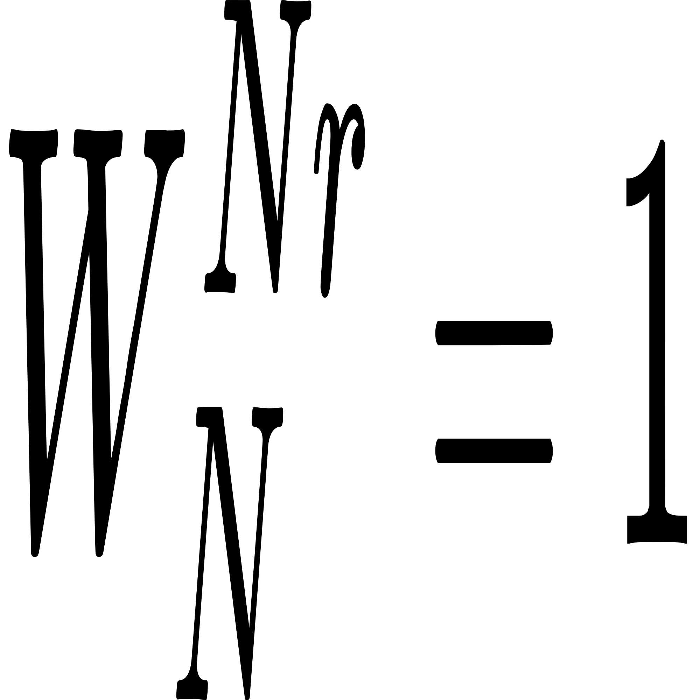

C:/Users/User/AppData/Local/Temp/wps.xrfmuHwps , 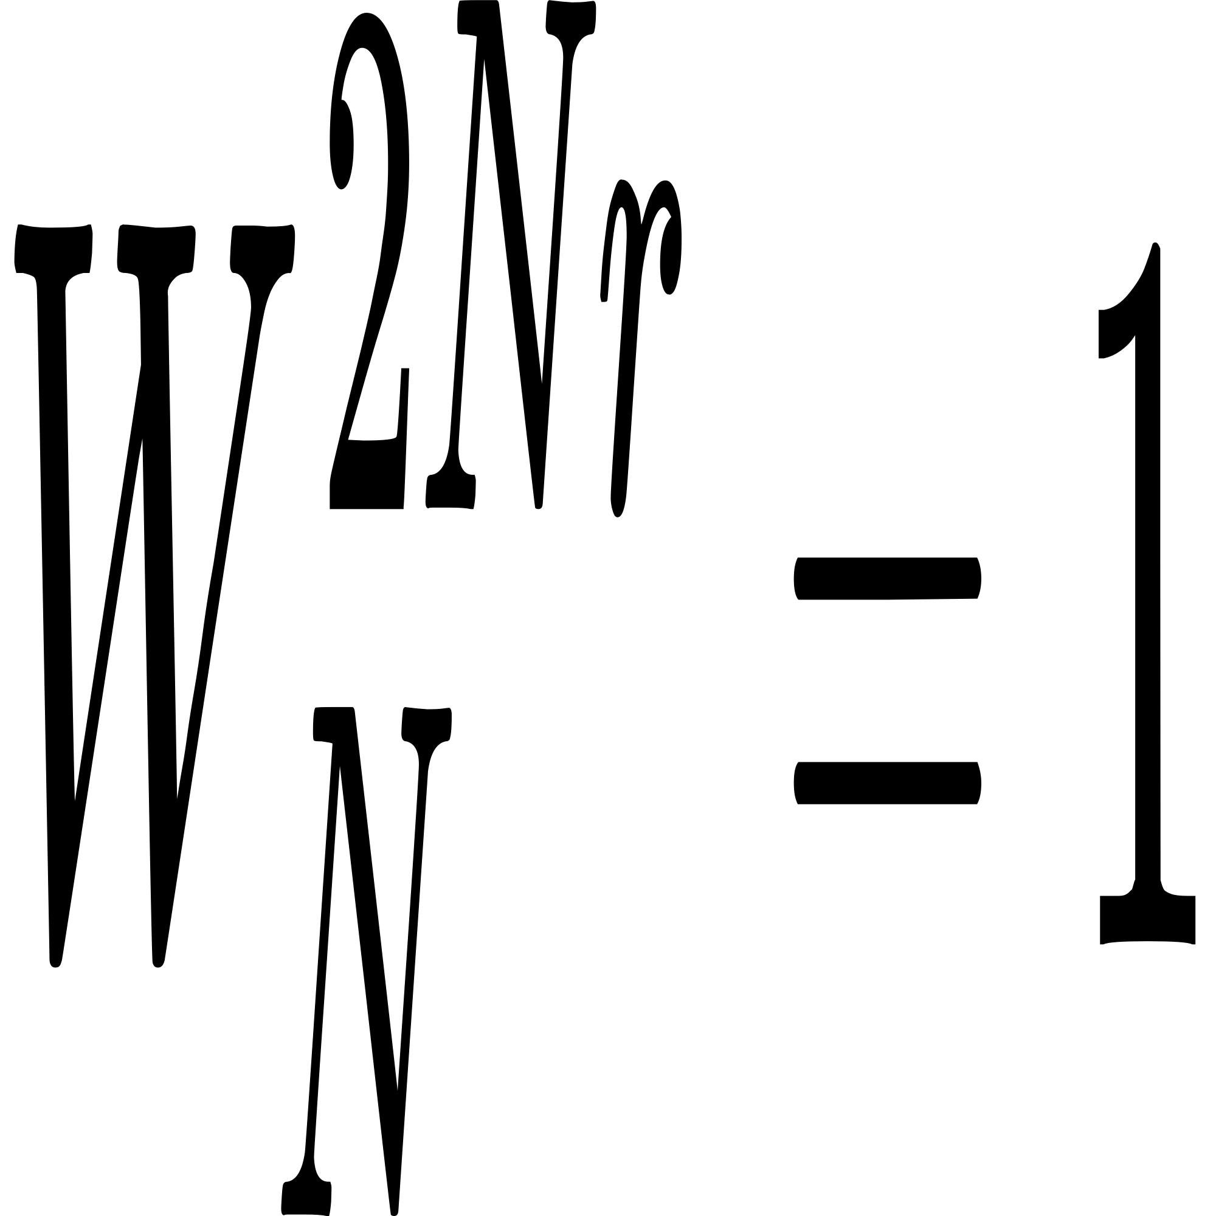

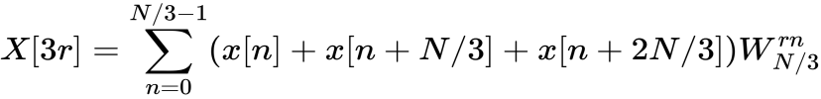

For k = 3r +1 where r = 0 ,…, N/3-1

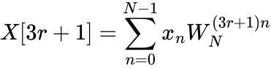

Split this over 3 sums with N/3 intervals.



C:/Users/User/AppData/Local/Temp/wps.YRLVwjwps

C:/Users/User/AppData/Local/Temp/wps.WRzQlowps , 

C:/Users/User/AppData/Local/Temp/wps.rOpIhVwps , 

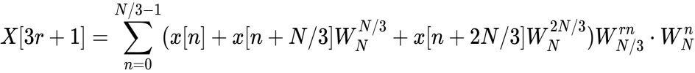

For k = 3r +2 where r = 0 ,…, N/3-1

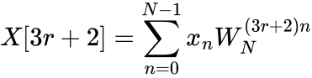

Split this over 3 sums with N/3 intervals.



C:/Users/User/AppData/Local/Temp/wps.cxJmYhwps

C:/Users/User/AppData/Local/Temp/wps.KlvXNUwps , 

C:/Users/User/AppData/Local/Temp/wps.kXqHeYwps , 



**b)**

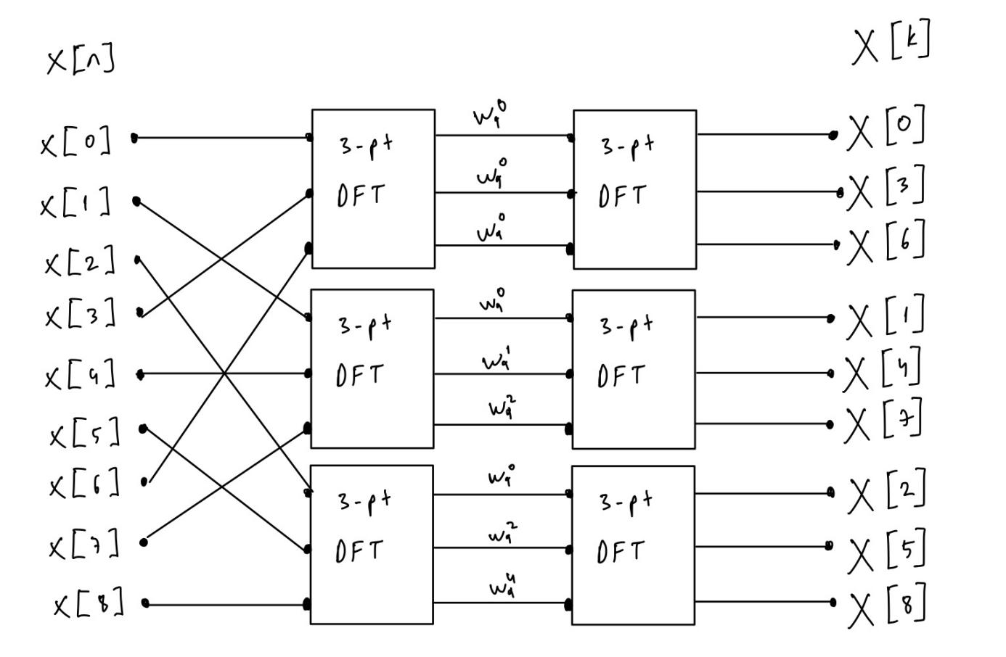

***Fig.21*** *Sample flow graph for the 9-pt decimation-in-frequency FFT algorithm.*

**c)**

First, a complex array of length N = 9 is created with the given code snippet:

rng(2,"twister")

N = 9;

real_part = randn(1,N);

imag_part = randn(1,N);

x = real_part + 1i*imag_part;

Real and imaginary parts of x[n] are plotted:

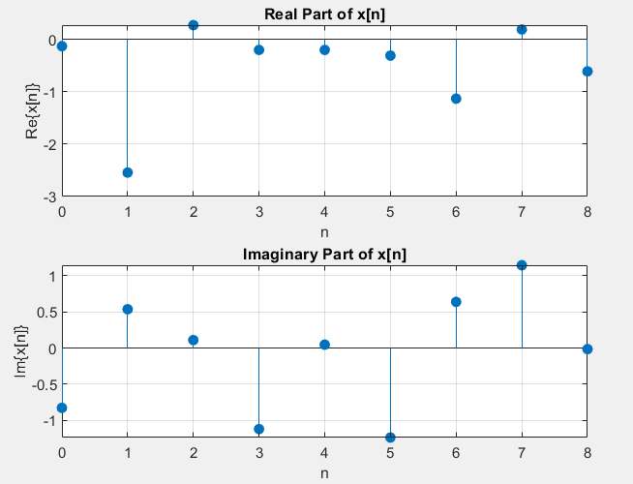

***Fig.22*** *Real and Imaginary parts of x[n], N= 9*

In order to compute DFT of array x using the DFT definition in summation form, the same function defined in ***Q1****) (b)*, **DFT_summation(x)**, has been called as in the following code snippet:

t1 = tic;

Xsum = DFT_summation(x);

elapsed_time = toc(t1);

fprintf('Elapsed time for DFT_summation is %.6f seconds.\n', elapsed_time);

plotDFT(Xsum, 'Summation Formula')

**d)**

In order to implment the 9-pt FFT using decimation-in-frequency algorithm derived in part (a) the following function is defined:

function X = nineptFFT(x)

N = length(x);

X = zeros(1, N);

for r = 0:(N/3 - 1)

for p = 0:2

temp = 0;

for n = 0:(N/3 - 1)

inner_sum = 0;

for l = 0:2

inner_sum = inner_sum + x(n + l*N/3 + 1) * exp(-1j*2*pi*p*l/3);

end

temp = temp + inner_sum * exp(-1j*2*pi*n*r/(N/3)) * exp(-1j*2*pi*p*n/N);

end

X(3*r + p + 1) = temp;

end

end

end

The DFT of x[n] found with the following code snippet:

t2 = tic;

X_9pt_fft = nineptFFT(x);

elapsed_time = toc(t2);

fprintf('Elapsed time for 9-pt FFT is %.6f seconds.\n', elapsed_time);

plotDFT(X_9pt_fft, '9-pt FFT')

**e)**

In order to compute DFT of x[n] using the MATLAB’s built-in FFT command, the fft command is called as follows:

t3 = tic;

X_fft = fft(x);

elapsed_time = toc(t3);

fprintf('Elapsed time for fft is %.6f seconds.\n', elapsed_time);

plotDFT(X_fft, 'FFT')

**f)**

In order to compare the results norm difference of the algorithms are computed following the same steps in ***Q1)*** *(h).*

The magnitude and phase graph of the different algorithms:

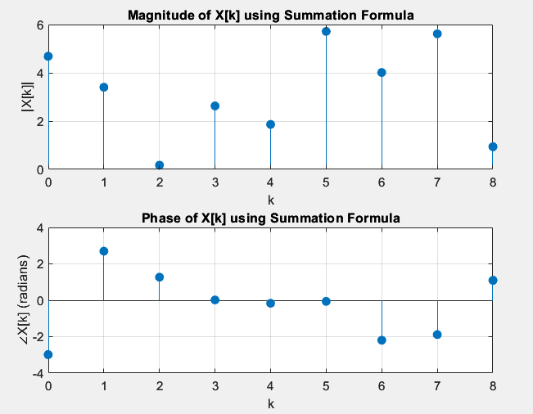

***Fig.23*** *DFT using summation formula, N = 9*

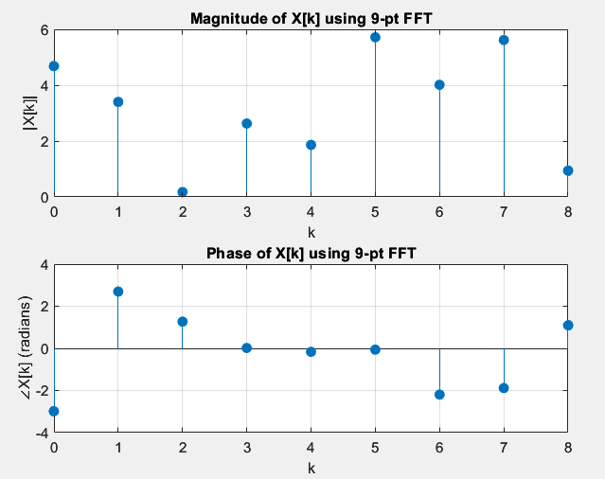

***Fig.24*** *DFT using 9-pt FFT DIF, N = 9*

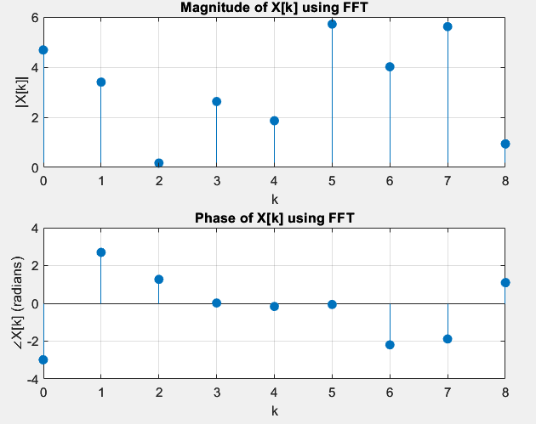

***Fig.25*** *DFT using FFT, N =* 9

Comparing Figures 23-25 it is visible that each algorithm produces equivalent results.

Differences of the norms of different algorithms:

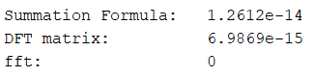

***Fig.26****Difference of the norms between the algorithms, N =* 9

From Fig.26 it is evident that the difference of the norms are very close to zero, therefore, all the algorithms generates the same result.

**g)**

Time it takes for each algorithm is calculated using *tic* and *toc* commands. The results are gathered in the Table 2.

|  |  |
| --- | --- |
| **Part** | **Time** |
| Part (c) | 0.000041 s |
| Part (d) | 0.000074 s |
| Part (e) | 0.000013 s |

***Table 2:*** *Time it takes to compute different DFT approaches, N = 9*

Table 2 shows the time taken by three different DFT approaches for DFT of length N = 9. As expected, there is a significant variation in time across different methods. These times indicate that the MATLAB built-in FFT function is still the fastest, as expected, with the custom 9-pt FFT slightly slower than both the summation method and the built-in function. Despite the minimal time differences, the overall performance aligns with expectations: built-in FFTs are highly optimized, while custom methods like the 9-pt FFT have higher overheads. 9-pt FFT DIF algorithm is slower than the direct summation because array length is too small N = 9. In ***Q1)*** *(k)* it is shown that for N = 32 FFT DIF algorithm is slightly slower than the direct summation but for N = 2^12 FFT DIF algorithm is significantly faster. Therefore, for a larger array like N = 3^8 the result could have been significantly faster.

**Appendicies**

**Appendix A - Q1 whole code**

close all

clear

clc

rng(2,"twister")

N = 32;

real_part = randn(1,N);

imag_part = randn(1,N);

x = real_part + 1i*imag_part;

steps_a_h(x);

rng(2,"twister")

N = 256;

real_part = randn(1,N);

imag_part = randn(1,N);

x = real_part + 1i*imag_part;

steps_a_h(x);

rng(2,"twister")

N = 2^12;

real_part = randn(1,N);

imag_part = randn(1,N);

x = real_part + 1i*imag_part;

steps_a_h(x);

function steps_a_h(x)

N = length(x);

fprintf('N = %d \n', N);

n = 0:N-1;

figure;

subplot(2,1,1);

stem(n, real(x), 'filled');

title('Real Part of x[n]');

xlabel('n');

ylabel('Re\{x[n]\}');

xlim([0 N-1]);

grid on;

subplot(2,1,2);

stem(n, imag(x), 'filled');

title('Imaginary Part of x[n]');

xlabel('n');

ylabel('Im\{x[n]\}');

xlim([0 N-1]);

grid on;

t1 = tic;

Xsum = DFT_summation(x);

elapsed_time = toc(t1);

fprintf('Elapsed time for DFT_summation is %.6f seconds.\n', elapsed_time);

plotDFT(Xsum, 'Summation Formula')

t2 = tic;

X_mat = DFT_matrix(x);

elapsed_time = toc(t2);

fprintf('Elapsed time for DFT_matrix is %.6f seconds.\n', elapsed_time);

plotDFT(X_mat, 'DFT matrix')

t3 = tic;

X_DIT = FFT_DIT(x);

elapsed_time = toc(t3);

fprintf('Elapsed time for FFT_DIT is %.6f seconds.\n', elapsed_time);

plotDFT(X_DIT, 'FFT-DIT')

t4 = tic;

X_DIF = bitrevorder(FFT_DIF(x));

elapsed_time = toc(t4);

fprintf('Elapsed time for FFT_DIF is %.6f seconds.\n', elapsed_time);

plotDFT(X_DIF, 'FFT-DIF')

t5 = tic;

X_fft = fft(x);

elapsed_time = toc(t5);

fprintf('Elapsed time for fft is %.6f seconds.\n', elapsed_time);

plotDFT(X_fft, 'FFT')

fprintf('\n');

disp(['Summation Formula: ', num2str(norm(X_fft - Xsum))]);

disp(['DFT matrix: ', num2str(norm(X_fft - X_mat))]);

disp(['FFT-DIT: ', num2str(norm(X_fft - X_DIT))]);

disp(['FFT-DIF: ', num2str(norm(X_fft - X_DIF))]);

disp(['fft: ', num2str(norm(X_fft - X_fft))]);

fprintf('\n');

end

function plotDFT(X, str)

N = length(X);

n = 0:N-1;

figure;

subplot(2,1,1);

stem(n, abs(X), 'filled');

title(['Magnitude of X[k] using ', str]);

xlabel('k');

ylabel('|X[k]|');

xlim([0 N-1]);

grid on;

subplot(2,1,2);

stem(n, angle(X), 'filled');

title(['Phase of X[k] using ', str]);

xlabel('k');

ylabel('∠X[k] (radians)');

xlim([0 N-1]);

grid on;

end

function X = FFT_DIF(x)

N = length(x);

if N == 1

X = x;

else

X = x;

% Butterfly stage

for k = 1:N/2

temp = X(k);

X(k) = temp + X(k + N/2);

X(k + N/2) = (temp - X(k + N/2)) * exp(-1i * 2 * pi * (k - 1) / N);

end

% Recursive stage

X(1:N/2) = FFT_DIF(X(1:N/2));

X(N/2+1:N) = FFT_DIF(X(N/2+1:N));

end

end

function X = FFT_DIT(x)

N = length(x);

if N == 1

X = x;

else

% Divide

x_even = x(1:2:end);

x_odd = x(2:2:end);

% Conquer

X_even = FFT_DIT(x_even);

X_odd = FFT_DIT(x_odd);

% Combine

WN = exp(-1i * 2 * pi / N);

W = 1;

X = zeros(1, N);

for k = 1:N/2

X(k) = X_even(k) + W * X_odd(k);

X(k + N/2) = X_even(k) - W * X_odd(k);

W = W * WN;

end

end

end

function X = DFT_matrix(x)

N = length(x);

WN = exp(-1i * 2 * pi / N);

DFT_mat = zeros(N, N);

for k = 0:N-1

for n = 0:N-1

DFT_mat(k+1, n+1) = WN^(k * n);

end

end

X = (DFT_mat * x.').';

end

function X = DFT_summation(x)

N = length(x);

X = zeros(1, N);

for k = 0:N-1

for n = 0:N-1

X(k+1) = X(k+1) + x(n+1) * exp(-1i * 2 * pi * k * n / N);

end

end

end

**Appendix B - Q2 whole code**

close all

clear

clc

rng(2,"twister")

N = 9;

real_part = randn(1,N);

imag_part = randn(1,N);

x = real_part + 1i*imag_part;

fprintf('N = %d \n', N);

n = 0:N-1;

figure;

subplot(2,1,1);

stem(n, real(x), 'filled');

title('Real Part of x[n]');

xlabel('n');

ylabel('Re\{x[n]\}');

xlim([0 N-1]);

grid on;

subplot(2,1,2);

stem(n, imag(x), 'filled');

title('Imaginary Part of x[n]');

xlabel('n');

ylabel('Im\{x[n]\}');

xlim([0 N-1]);

grid on;

t1 = tic;

Xsum = DFT_summation(x);

elapsed_time = toc(t1);

fprintf('Elapsed time for DFT_summation is %.6f seconds.\n', elapsed_time);

plotDFT(Xsum, 'Summation Formula')

t2 = tic;

X_9pt_fft = nineptFFT(x);

elapsed_time = toc(t2);

fprintf('Elapsed time for 9-pt FFT is %.6f seconds.\n', elapsed_time);

plotDFT(X_9pt_fft, '9-pt FFT')

t3 = tic;

X_fft = fft(x);

elapsed_time = toc(t3);

fprintf('Elapsed time for fft is %.6f seconds.\n', elapsed_time);

plotDFT(X_fft, 'FFT')

fprintf('\n');

disp(['Summation Formula: ', num2str(norm(X_fft - Xsum))]);

disp(['DFT matrix: ', num2str(norm(X_fft - X_9pt_fft))]);

disp(['fft: ', num2str(norm(X_fft - X_fft))]);

fprintf('\n');

function X = nineptFFT(x)

N = length(x);

X = zeros(1, N);

for r = 0:(N/3 - 1)

for p = 0:2

temp = 0;

for n = 0:(N/3 - 1)

inner_sum = 0;

for l = 0:2

inner_sum = inner_sum + x(n + l*N/3 + 1) * exp(-1j*2*pi*p*l/3);

end

temp = temp + inner_sum * exp(-1j*2*pi*n*r/(N/3)) * exp(-1j*2*pi*p*n/N);

end

X(3*r + p + 1) = temp;

end

end

end

function X = DFT_summation(x)

N = length(x);

X = zeros(1, N);

for k = 0:N-1

for n = 0:N-1

X(k+1) = X(k+1) + x(n+1) * exp(-1i * 2 * pi * k * n / N);

end

end

end

function plotDFT(X, str)

N = length(X);

n = 0:N-1;

figure;

subplot(2,1,1);

stem(n, abs(X), 'filled');

title(['Magnitude of X[k] using ', str]);

xlabel('k');

ylabel('|X[k]|');

xlim([0 N-1]);

grid on;

subplot(2,1,2);

stem(n, angle(X), 'filled');

title(['Phase of X[k] using ', str]);

xlabel('k');

ylabel('∠X[k] (radians)');

xlim([0 N-1]);

grid on;

end